**KWAME NKRUMAH UNIVERSITY OF SCIENCE AND TECHNOLOGY**

**COLLEGE OF ENGINEERING**

**DEPARTMENT OF COMPUTER ENGINEERING**



**AN INTERMITTENT PNEUMATIC COMPRESSION DEVICE TO PREVENT DEEP**

**VEIN THROMBOSIS**

By

Ameyaw Samuel Arthur

Clayman Agnes

March 2024

DECLARATION

"We, the undersigned, hereby declare that this project report titled 'An Intermittent Pneumatic Compression Device to Prevent Deep Vein Thrombosis' is our original work and has not been submitted elsewhere for publication or academic credit.

We also declare that we have duly acknowledged all sources of information and assistance received in the preparation of this report.

DEDICATION

This project is dedicated to every Ghanaian who has lost a loved one due to complications arising from deep vein thrombosis. We cannot bring back your loved one, but we hope that the outcome of this project brings you comfort.

ACKNOWLEDGEMENT

Our first and utmost gratitude goes to God Almighty for granting us with wisdom and skills to undertake this project.

We thank our supervisor, for his constant support and motivation. Without his important counsel and unwavering patience over the course of this project's development, this project would not have been possible, and we are grateful to him for that.

A big thank you to the teaching assistants for their selfless efforts in directing us throughout the project.

Special thanks to Biomedical Engineering four for willingly supporting us with your abilities.

To our parents, siblings, and friends, we are grateful for their love and encouragement throughout the project.

ABSTRACT

It is necessary for the veins in the body to return blood back to the heart. In a case where there is stasis or injury in the vein, there is a possibility of blood clots forming. Although the body’s natural response to injury is the formation of blood clots, not all blood clots are desirable.

A case where blood clots form in the deep vein of the body is known as deep vein thrombosis. Deep vein thrombosis on its own is not fatal but in a case where the blood clots break off and travel to the lungs, it can lead to pulmonary embolism, a condition with a high fatality rate.

The goal of this project is to build an intermittent pneumatic compression device that will prevent the formation of undesirable blood clots in the calf and thus, preventing deep vein thrombosis

**TABLE OF CONTENTS**

INTRODUCTION 1

BACKGROUND OF STUDY 1

PROBLEM STATEMENT 2

RESEARCH OBJECTIVES 2

General Objectives 2

Specific Objectives 2

SIGNIFICANCE OF STUDY 2

SCOPE OF WORK 3

ORGANISATION OF STUDY 3

LITERATURE REVIEW 4

PHYSIOLOGY OF BLOOD FLOW 4

Risk Factors for DVT 6

Diagnosis of DVT 8

TREATMENT FOR DEEP VEIN THROMBOSIS 9

Anticoagulants 9

Thrombolytics 9

Thrombectomy 10

DEEP VEIN THROMBOSIS PROPHYLAXES 11

Foot Pumps 11

Graduated Compression Stockings 12

INTERMITTENT PNEUMATIC COMPRESSION DEVICE 12

History of IPC Systems 12

Effect of Intermittent Pneumatic Compression Devices on Venous Blood Flow Velocity 13

Factors Affecting IPC Systems 14

Foot, Calf and Thigh Compression 14

Complications of Intermittent Pneumatic Compression Devices 15

METHODOLOGY 16

DESIGN PROCESS 16

SYSTEM ARCHITECTURE 17

SYSTEM DESIGN 17

Compression Unit 17

Power Supply Unit 19

Display System 19

Sensor Unit 20

Microcontroller 20

Circuitry 21

Flowchart for IPC Device 24

BUILDING AND TESTING 25

THE CUFF 25

THE CHASSIS 26

TESTING AND EVALUATION 29

Leakage Test 29

Tensile Strength of Bladder 29

Sensitivity of Air Pressure Sensor 29

Adhesive Strength of Velcro 30

Constriction of Popliteal Vein 30

Refilling of Popliteal Vein 30

CONCLUSION AND RECOMMENDATION 31

ASSESSMENT OF OBJECTIVES 31

CHALLENGES 31

RECOMMENDATIONS 32

APPENDIX 33

CODE IMPLEMENTATION 33

3D MODEL OF DEVICE 35

BILL OF MATERIALS 36

REFERENCES 37

**TABLE OF FIGURES**

Figure 1: Physiology of Blood Flow ............................................................................................................... 4

Figure 2: Pulmonary Embolism ..................................................................................................................... 6

Figure 3: System Architecture ..................................................................................................................... 18

Figure 4: Pneumatic Pump .......................................................................................................................... 19

Figure 5 Cuff ................................................................................................................................................ 20

Figure 6 Solenoid Valve ............................................................................................................................... 20

Figure 7: Liquid Crystal Display ................................................................................................................... 21

Figure 8: Air Pressure Sensor ...................................................................................................................... 22

Figure 9: Arduino Uno Microcontroller....................................................................................................... 22

Figure 10 Breadboard Connection of IPC Device ........................................................................................ 23

Figure 11 Schematic Diagram of IPC Device ............................................................................................... 23

Figure 12 Flowchart Showing Algorithm ..................................................................................................... 25

Figure 13 Built Cuff...................................................................................................................................... 27

Figure 14 Breadboard Connections ............................................................................................................ 27

Figure 15 IPC Device .................................................................................................................................... 28

Figure 16 IPC Device in Inflation Phase ....................................................................................................... 28

Figure 17 IPC Device in Deflation Phase ..................................................................................................... 29

Figure 18 Code Implementation for IPC Device 1 ....................................................................................... 34

Figure 19 Code Implementation of IPC Device 2 ........................................................................................ 35 Figure 20 Code Implementation of IPC Device 3 ........................................................................................ 36

# INTRODUCTION

## BACKGROUND OF STUDY

The circulatory system consists of blood vessels (veins, arteries and capillaries) which are responsible for the transport of blood, oxygen and nutrients throughout the body. Veins carry blood to the heart except the pulmonary vein which carries blood away from the heart. There are three types of veins; superficial veins, connecting veins and deep veins. Superficial veins are located under the fatty layer of the skin and move blood slowly. Deep veins are found deep inside your body, in the muscles or along bones. Connective veins like the name suggests direct blood from the superficial veins to the deep veins and not vice versa [1].

A common condition that occurs in this transport process is deep vein thrombosis (DVT). Deep vein thrombosis occurs when blood clot forms in the deep veins due to stasis, hypercoagulability or blood vessel injury. This condition becomes most serious when the blood clot travels through the bloodstream to the lungs causing a blockage, a condition known as pulmonary embolism which is fatal.

Prophylaxes for deep vein thrombosis include;

· Anticoagulants

· Graduated compression stockings

· The use of compression devices on the calves to stimulate the contraction of the muscles.

Deep vein thrombosis is prevalent everywhere in the world, including Ghana. Unfortunately, there are no recorded statistics to show how common deep vein thrombosis is in Ghana. Taking the United States of America as a case study, deep vein thrombosis affects 900,000 Americans with up to 100,000 of them dying every year [1]. In the United Kingdom, deep vein thrombosis affects one in every 1000 people every year [2].

## PROBLEM STATEMENT

The standard treatment guidelines released by the Ghana Ministry of Health in 2017 indicates that the pharmacological treatment given to patients who suffer deep vein thrombosis is the use anticoagulants such as heparin, enoxaparin and warfarin [3]. However, anticoagulants cannot be used by everyone due to the complications of excessive bleeding.

Upon further research, it was realized the cost of the compression device ranges from $89 to $329 which is expensive for the average Ghanaian.

Our problem statement is that **there are no affordable compression devices in Ghana to aid in the prevention of deep vein thrombosis**.

## RESEARCH OBJECTIVES

The objectives of this project are what we intend to accomplish by the end of this project. These objectives are divided into two categories; general objectives and specific objectives.

### General Objectives

The general objective of this work, which is our main goal, is to build an affordable intermittent pneumatic compression device to prevent deep vein thrombosis.

### Specific Objectives

1. Utilise available and affordable components in the Ghanaian market.
2. Incorporating computer aided design for 3d model of device
3. Applying knowledge of programming and electronics to build device.
4. Testing and validation of device.

## SIGNIFICANCE OF STUDY

The complication arising from deep vein thrombosis (pulmonary embolism) is fatal and needs to be addressed. Existing interventions merely treat DVT and not prevent it. Developing a device that would prevent abrupt death due to pulmonary embolism and would lower the rate at which individuals develop deep vein thrombosis is very important.

This device would also be affordable and hence can be purchased by individuals who sit or travel for long periods and the hospital and so the significance of this project cannot be overemphasised.

## SCOPE OF WORK

This project is aimed at bedridden patients in the hospital, especially those from surgery and childbirth. However, patients who have been discharged after surgery can also use it at home for the recovery period.

## ORGANISATION OF STUDY

1. The first chapter is the introduction of the project which considers the background of study, problem statement, research objectives, significance of study and the scope of work.
2. The second chapter is the literature review. It is a compilation of all data obtained from journals, books, research papers and other valuable resources which are related to our line of work and outlines the successes and failures of previous works. It discusses deep vein thrombosis, existing interventions and intermittent pneumatic compression.
3. The third chapter is the methodology. This contains the processes and methods used in the design of this project. It has answers to the questions of what, where and how the project was done right from the proposal of the design to the implementation of the finished work.

# LITERATURE REVIEW

## PHYSIOLOGY OF BLOOD FLOW

The circulatory system is made up of veins, capillaries, arteries and heart. Its main function is to circulate blood through the body. Arteries are responsible for carrying blood away from the heart and veins carry blood to the heart. The veins found in the body can be superficial or deep. Superficial veins are found close to the surface of the body while deep veins are found closer to the muscles in the body. The capillaries are the smallest vessels and facilitate the exchange of nutrients and oxygen between the blood and the tissue cells through diffusion.

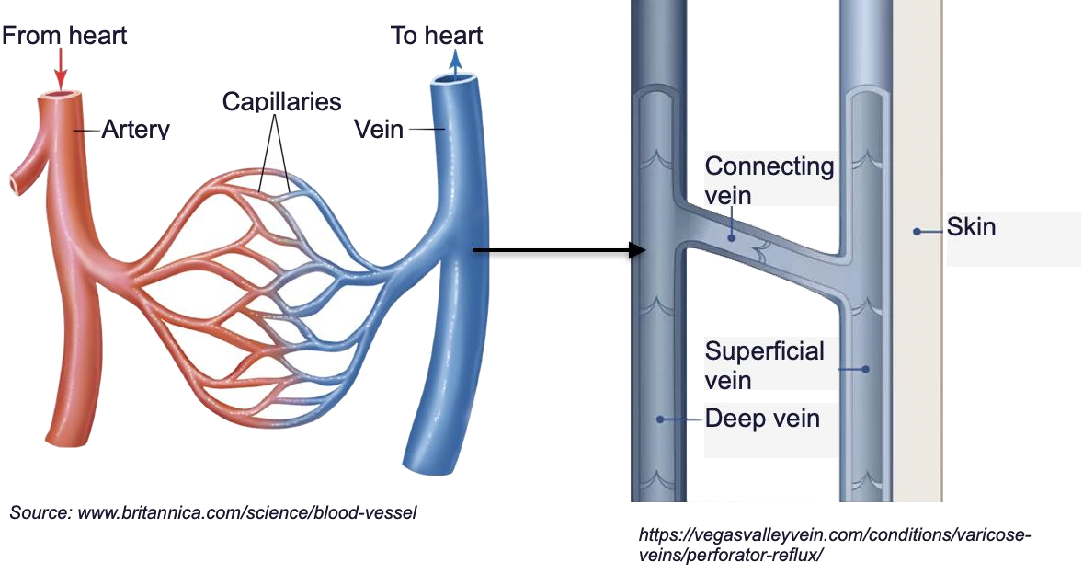

*Figure 1: Physiology of Blood Flow*

**Haemodynamics** is the study of the flow of blood through the blood vessels and factors that affect blood flow. Blood flow is the volume of blood flowing through a particular vessel in each interval of time. As blood flows through blood vessels, it exerts some form of pressure on the walls of the vessels. Blood flows from a region of high pressure to a region of low pressure that is from the arteries to the capillaries and finally the veins [4]. Because of the pumping mechanism in the heart, blood flows out of the heart with high pressure and drops as it circulates around the body. Blood flow is expressed as a change in pressure over the resistance.

The rate at which blood flows is known as its velocity and this velocity is inversely proportional to the cross-sectional area of the blood vessel [4]. Blood flow velocity in the vein is dependent on the diameter of the vein. For instance, there is increased blood flow during vasodilation than during vasoconstriction due to the increased area of the vessel however, the rate at which this blood flows is slower. Blood flow is slowest in the capillaries to allow for exchange of gases and nutrients. When blood leaves the capillaries into the veins, little pressure is left and so the veins rely on muscle contraction and respiratory movements to send blood back to the heart.

**Haemostasis** is the process of blood clot formation at a vessel injury site. Blood clotting is an immune response of the body. Haemostasis occurs in four stages. First, there is vasoconstriction, the narrowing of the red blood vessels which reduces the amount of blood flowing to the site of injury. In the second phase, platelets found in the blood form a platelet plug within twenty seconds of injury. These platelets secrete fibrin strands which aid in the platelet plug formation by binding them together. Collagen which are proteins found in the subendothelial of the blood vessels adhere to and activate the platelets causing them to swell, grow filaments and aggregate or in other words clump together. Von Willebrand factor mediates platelet adhesion to the damaged vascular surface. The injury is completely sealed after this. Blood clot formation begins in the third phase. This is a reinforcement for the platelet plug if it is not strong enough to stop bleeding. Platelets have secretory granules which release their products (adenosine diphosphate, serotonin, and thromboxane A2) after they degranulate to activate other platelets. There are twelve clotting factors that take place in this coagulation process, a cascade of chemical reactions that create a mesh of fibrin in the blood. Each of these clotting factors has a specific function. Prothrombin, thrombin and fibrinogen are the main factors involved in the coagulation cascade Damaged vessels and nearby platelets release prothrombin activator which activates the conversion of prothrombin, a plasma protein to thrombin, an enzyme which further facilitates the conversion of soluble fibrinogen to fibrin. Fibrins are fibres which traps and holds platelets and blood cells tight to the site of injury. Finally, the platelets in the clot shrink, tightening the vessel walls to start wound healing [5]. This process is known as fibrinolysis.

DEEP VEIN THROMBOSIS

**Deep Vein Thrombosis** (DVT) is a condition where blood clots are formed in the deep vein of the body, usually in the lower limb. The cause of deep vein thrombosis has been described Rudolph Virchow, known as the Virchow’s triad which includes venous stasis, vascular injury and hypercoagulability [6]. The blood clots slow down blood flow in the veins and this causes blood to pool and makes the affected area appear inflamed. DVT becomes a serious condition when the blood clot (embolus) breaks off and travels to the heart where it goes to the pulmonary artery and into the lungs. These clots can cause a blockage of the lungs and the condition is known as **Pulmonary Embolism**. Pulmonary embolism is the third most common cause of death from cardiovascular disease after heart attack and stroke [7]. A condition where deep vein thrombosis occurs together with pulmonary embolism is termed **Venous Thromboembolism**.

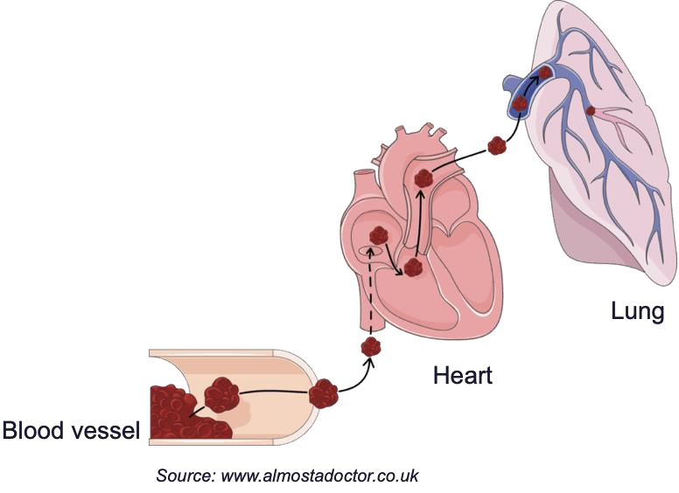

*Figure 2: Pulmonary Embolism*

The symptoms of deep vein thrombosis are inflammation (redness and swelling) and pain in the affected area and possibly a mild fever. However, about half of people diagnosed with DVT have no symptoms [1].

### Risk Factors for DVT

Several risk factors, both inherited and acquired have been studied and associated with deep vein thrombosis. These include obesity, smoking, surgery (during and after), old age, birth control pillls and contraceptives, family history, blood clotting disorders and cancer.

All surgeries, especially orthopedic, heart bypass and neurovascular surgeries have a higher risk of DVT due to prolonged surgical times and post-surgical immobilization times [6]. During surgeries, tissue, debris, fats or collagen could get released into your blood stream making blood thicker around those particles. Damaged veins during operation could cause the formation of blood clots. Also, surgeries that involve scrapping or cutting into a bone, such as hip replacement may release antigens that could trigger the body’s immune system and lead to the formation of blood clots [8].

Malignancies, like cancer are associated with hypercoagulability (increased tendency to develop blood clots). In lymphoma, cancer of the lymph, there is vascular compression by surrounding enlarged lymph nodes in the pelvis or abdomen [5]. The type of cancer could also lead to deep vein thrombosis. It is common in patients with lung, brain, pancreatic and ovarian cancers [9]. The malignant cells in cancer patients produce tissue factor that triggers the coagulation cascade leading to the formation of factor Xa, a protein that catalyses the production of thrombin and leads to clot formation and wound closure. The use of chemotherapy also contributes to thrombolysis [10]. Medications like tamoxifen and epoetin used in chemotherapy lower the anticoagulation factors of the blood and increase the coagulation factors increasing blood clot formation. Also, cancer and its treatment make patients feel too tired and weak to move around freely. Blood flow in your leg veins depends on the squeezing of the veins by the leg muscles when you walk. Immobility reduces blood flow in the legs and blood can stagnate in the legs and become sticky, increasing the risk of blood clots [11].

Obesity raises and alters the levels of factors that affect coagulation and blood clotting. There is an over production of adipokines such as leptin and adiponectin in obese individuals which causes them to develop insulin resistance and a chronic inflammatory state increasing platelet activity. Again, there is an overproduction of plasminogen activator inhibitor-1 from fat cells (adipocytes) and liver cells (hepatocytes) that leads to the inhibition of fibrinolysis (clot breakdown) promoting blood clot formation and raising the risk of deep vein thrombosis [12].

Chronic smokers can also develop DVT because the nicotine in the cigarette increases the number of platelets in the blood and makes them sticky and more likely to clump together creating more blood clots. Damage is also incurred in the lining of the blood vessels which can cause clots to form [13].

Women are at a risk for blood clots during pregnancy, childbirth, and after pregnancy. During pregnancy, a woman’s blood clots more easily to prevent haemorrhage during delivery [14]. Blood flow to the legs is reduced later in pregnancy because the blood vessels around the pelvis are pressed up by the growing baby [15]. These blood clots can be dangerous for the mother and the developing baby because they can cut off blood flow to the developing baby. Also, surgical delivery by C-section nearly doubles a pregnant woman’s risk for a dangerous blood clot. After delivery, there is limited or lack of movement due to bed rest that can limit the flow of blood in the legs and arms increasing a woman’s risk for blood clot. Pregnancy is a high-risk factor for DVT due to the obstruction of the inferior vena cave by the uterus. The probability is higher post childbirth and in multiple pregnancies [6].

### Diagnosis of DVT

Diagnosis of deep vein thrombosis (DVT) requires a multifaceted approach that includes clinical assessment, evaluation of pre-test probability, and objective diagnostic testing. The pre-test probability of DVT can be assessed using a clinical decision rule that stratifies DVT into “unlikely” or “likely” [16]. If unlikely, d- dimer test is done and if result is uncertain, the test is followed by an ultrasound. However, if the pre-test probability is likely, a duplex ultrasound is done right away.

Duplex ultrasound is an imaging technique used to detect DVT. It is non-invasive, relatively inexpensive and readily available in most hospitals. It combines ultrasound imaging and Doppler technology for the diagnosis. Ultrasound imaging allows the viewing of the blood vessels whereas the doppler technology produces an audible and graphic representation of blood flow [17]. Doppler technology uses the change in sound waves due to motion to understand the flow of blood within tissues. The transducer is made up of piezoelectric crystals which convert electrical activity to ultrasound waves and back to electrical activity [18].

D-dimer test is a blood test that measures the levels of a substance called D-dimer in the blood. Ddimer is a by-product of the breakdown of blood clots. The typical D-dimer level is less than 0.50mg/L [19]. Elevated levels of D-dimer can indicate the presence of a blood clot in the body. The D-dimer test is often used as a screening tool for DVT, but it is not as specific as ultrasound in detecting DVT. Even though it has reliable results, it cannot identify where the blood clot is.

Venography is another technique used in detecting DVT. This is an invasive test that involves injecting a contrast iodine-based dye into the veins of the legs. X-ray images are taken of the dye flowing through the veins towards the heart. This allows physicians to see major obstructions in the leg vein [20]. Venography is highly accurate in detecting DVT, but it is rarely used due to its invasive nature and the pain associated with it.

## TREATMENT FOR DEEP VEIN THROMBOSIS

### Anticoagulants

Anticoagulants, also known as blood thinners, are medications that reduce the body’s ability to form a blood clot. The act at different sites of the coagulation cascade either directly by inhibiting enzymes or indirectly by preventing the formation of antithrombin in the liver [21]. They are commonly used to treat and prevent blood clots in conditions such as deep vein thrombosis, pulmonary embolism, and stroke. Some examples of anticoagulant medication include warfarin, heparin, enoxaparin, and dabigatran. These medications are typically prescribed by a healthcare professional and require careful monitoring to ensure proper dosing and prevent side effects such as bleeding.

Complications

1. Presence of blood in urine
2. Severe bruising
3. Indigestion
4. Dizziness

### Thrombolytics

Thrombolytics, also known as clot busters, are a class of drugs that are used to dissolve blood clots that can cause heart attacks, strokes, and other serious conditions. These drugs have been instrumental in saving countless lives and preventing long-term damage to vital organs.

Thrombolytics work by dissolving the blood clots that can form in the arteries and veins of the body. These clots can block blood flow to vital organs such as the heart, brain, and lungs, leading to serious complications and even death. By dissolving the clot, thrombolytics can restore blood flow to these organs and prevent further damage. There are several types of thrombolytics available, including streptokinase, alteplase, and tenecteplase. Each of these drugs works in a slightly different way and is used to treat different types of blood clots. For example, streptokinase is often used to treat blood clots in the legs, while alteplase is used to treat heart attacks and strokes.

Complications

1. Excessive bleeding
2. Fever
3. Nausea

#### Inferior Vena Cava Filter

An inferior vena cava (IVC) filter is a material inserted in the interior vena cava to trap blood clots. It is usually used in place of anticoagulant for patients that cannot receive anticoagulant medication. The inferior vena cava is a large vein in the body that returns blood from the lower part of the body and back to the heart. Because of the risk of blood clots travelling to the heart and being pumped into the lungs, an IVC filter is inserted to trap the blood clots. IVC filters are usually made of titanium, nitinol or stainless steel.

An IVC filter is inserted into the body through an incision at the femoral vein with the aid of a catheter and is moved to the inferior vena cava. Although it collapses when inserted, because of the shape memory feature of the material, it can expand and attach itself to the walls of the inferior vena cava [22].

Complications

1. It is invasive
2. Possibility of thrombosis at access site
3. Tilting of IVC filter leads to failure in filter retrieval [23].

5. Incomplete opening of the filter can lead to failure.

### Thrombectomy

is a surgery carried out to remove a blood clot from artery or vein. The blood clot is removed with the image guidance of an endovascular device [24]. Two general procedures exist for thrombectomy. The first is a surgical thrombectomy where the surgeon opens a blood vessel and extracts the clot with a vacuum or a catheter. The second is a percutaneous thrombectomy where the surgeon removes the thrombus by suction using wide bore catheters or variety of automated devices to remove the embolus [25]. Thrombectomy however could lead to excess bleeding, damage to the blood vessel, an infection and pulmonary embolism.

## DEEP VEIN THROMBOSIS PROPHYLAXES

The approaches taken to prevent deep vein thrombosis range from anticoagulants to electrical stimulation and to intermittent compression. Some of these approaches produce a better result when combined while some methods have been phased out.

#### Electrical Stimulation

Studies have shown that electrical current can be applied to the calf muscle to stimulate contraction during surgical operations. Two electrodes are attached to the upper and lower end of the gastrocnemius muscle with an electrolyte separating the skin from the electrode to reduce the possibility of burning [26]. A stimulus with a pulse width of 50 milliseconds produced a plantar flexion of the foot without violent movement of the leg. 15 pulses per minute was noted as the optimal electrical calf stimulus. The muscle contractions increased the blood flow velocity in the femoral vein.

Complications

1. Electrical stimulation cannot be used during postoperative period for conscious patients because it is painful [26].
2. Cannot be used conveniently on patients undergoing orthopaedic surgeries.
3. Electrodes are likely to cause blisters and burns [27].

### Foot Pumps

Foot pumps are used to help prevent deep vein thrombosis in patients who are immobile or bedridden by increasing venous blood flow.

The plantar venous plexus in the sole of the feet act as a built-in return pump. The plantar venous plexus flattens, stretches, and squeezes every time the foot strikes the ground, sending blood back up to the heart.

The foot pump mimics the action of walking by inflating a small balloon that presses on the bottom of your foot. The pressure from the inflated balloon activates the plantar venous plexus and sends blood back up to your heart.

### Graduated Compression Stockings

Graduated compression stockings (GCS) are socks worn to prevent the formation of blood clots by applying varying amounts of pressure to the different parts of the leg. GCS are usually made from nylon or cotton and are designed to deliver a high pressure (about 18 mmHg) at the ankle and a lower pressure of about 11 mmHg at the knee. Graduated compression stockings are very effective in preventing deep vein thrombosis when used together with anticoagulants. The compression intensity of the stockings gradually decreases as they are worn up the leg, beginning at the ankle where it is most intense. Blood travels upward into the heart because of the pressure gradient rather than refluxing laterally into the superficial veins or downward to the foot. The application of adequate graduated compression reduces the diameter of deep veins, which increases the velocity and volume of blood flow [28].

Complications

1. Allergy to stocking material.
2. Pressure sores.
3. Patient noncompliance due to discomfort [28].

## INTERMITTENT PNEUMATIC COMPRESSION DEVICE

An intermittent pneumatic compression (IPC) device is an equipment that applies pneumatic cuffs, connected to pump to the limbs. It is a therapeutic device aimed at mimicking the compression of the blood vessels during muscle contraction and to this effect, preventing the occurrence of deep vein thrombosis.

### History of IPC Systems

In 1925, Sir Thomas Lewis conducted a study on the compensatory increase in arterial flow observed after ischemia. During this study, it was discovered that an identical reaction occurred when the limb is compressed at low pressures. At this low pressure, the compression affected the veins and not the arteries [29]

In 1934, Mont Reid and Louis Hermann proposed the use of alternating pressure and suction in a passive vascular exercise to treat different forms of lower extremity arterial diseases. They designed an equipment, ‘Pavex’ made up of a control box and a chamber. The patient placed their limbs into the chamber and the limbs were subjected to varying levels of positive and negative pressure. During their research, they noticed that 20-40 mmHg of positive pressure and 80 mmHg of negative pressure for a duration over 20 seconds improved arterial blood flow in the patients [30]. The application of suction and pressure came with two complications. They were large and expensive and required attendance at the hospital for each session. Another complication was that the pressure chambers only covered a limb and so there was a need for an air-tight seal around the upper thigh or arm [29].

In 1936, William Collens and Nathan Wilensky built upon the study conducted by Sir Lewis and realised that the effect of the low pressure on the limbs could be therapeutic to arteriosclerotic patients [31] . The CollWil pump was designed after and improved symptoms of arterial diseases. This was the first significant commercial system designed because it was based on real physiological evidence [32] .

### Effect of Intermittent Pneumatic Compression Devices on Venous Blood Flow Velocity

Venous blood flow velocity as discussed earlier is the rate at which blood flows through the leg. It can be measured using a doppler ultrasound, a non-invasive test used to estimate blood flow through the blood vessels.

The intermittent pneumatic compression device is made up of two phases; sequential compression and simultaneous deflation.

Because there is compression when an IPC device is used, it has the capacity to augment blood flow in the deep veins of the lower limb. The veins are squeezed and emptied during the compression phase and are refilled during the deflation phase [33] .

In the femoral vein, at rest, the mean peak venous velocity (PVV) is 23.8 cm/s. When an IPC device is applied to the calf at peak compression (approximately 45 mmHg), the mean PVV increases to 40-60 cm/s [34].

### Factors Affecting IPC Systems

1. Cuff: The cuff or compression garment contain air bladders that exert pressure on the calf when inflated. The air bladders in the cuff could be circumferential or non-circumferential. Circumferential bladders cover the entire limb and require powerful air pumps to produce fast inflation rates. Non-circumferential bladders only compress along the circumference of the limb and need small input of air.
2. Pressure: The pressure applied during intermittent pneumatic compression is a compromise between patient comfort and efficiency. DVT prophylaxis at the calf does not require a high pressure. An average pressure of 40 mmHg is enough to empty the veins of the calf. However, in the foot, there is a small volume of blood stored in the venous plexus and requires much higher pressure (about 130 mmHg and higher) to cause emptying of the vein. It is also necessary to consider the comfort of the patient because if they do not use the system, there will be no prophylaxis [29] .
3. Compression Type: When air is sent to the bladders wrapped around the calf, there is compression at the calf. An IPC system can have three types of compression; uniform, graded sequential and sequential compression. Uniform compression occurs when a single pressure is applied to the limb under compression simultaneously. Graded sequential compression occurs when a gradient of pressure is produced by inflating each air bladder within the cuff to different pressure. This type of compression uses multiple bladders to compress the leg into a “milking action” [29] . Sequential compression involves a single pressure being applied to parts of a limb in sequence, with multiple bladders [35]. Studies have been carried out to compare the better compression type and although graded sequential time extends the augmentation period for about two seconds, the main objective of an IPC system is to prevent DVT. The studies carried out have shown that there is no conclusive evidence to show that any of the current compression types are significantly better than the others in the prevention of deep vein thrombosis [36], [37].

### Foot, Calf and Thigh Compression

In health, the volume of leg is maintained in equilibrium where the amount of arterial blood entering the leg is equal to the amount of venous blood flowing to the heart [38] Compression is used extensively in clinical practice to augment venous flow return [38]. Lower limb compression comes in a lot of varieties; foot compression, calf compression, foot and calf compression, calf and thigh compression and whole lower limb compression.

Calf compression needs a velocity of 40mmHg whereas foot compression needs a relatively higher pressure of about 130mmHg or more since the muscles of the foot are less readily compressible as compared to that of the calf [39]. The venous volume ejected by foot compression is lower than that of the calf compression. Thigh compression on the other hand cannot be done in isolation. It is done in conjunction with calf compression [38].

In a case study where the haemodynamic effect of the IPC is compared between the foot, calf, and both using duplex ultrasonography, pressures of 120mmHg and 180mmHg were applied to the foot, the calf and both simultaneously. It was observed that the compression of both produced the highest enhancement followed by the compression of the calf which was more effective than that of the foot [34].

All these modes of compression are effective. However, compression of the foot and calf generates the highest venous outflow enhancement and hence has a superiority on leg inflow over the other modes [40].

### Complications of Intermittent Pneumatic Compression Devices

Intermittent pneumatic compression devices come with their own complications; however, these effects are not so significant or life threatening.

1. Neurovascular compression: Neurovascular compression occurs because of pressure on a nerve by a blood vessel [41]. When there is an increase in pressure or prolonged compression of IPCs on the lower limbs during surgery [42], there is an increased risk of neurovascular compression.
2. Acute compartment syndrome: Patients, like women in labour or individuals with kidney stones who undergo surgery in the lithotomy position where they lie in a supine posture with the legs apart and supported with raised stirrups on sides above the remaining body [43], are at a risk of acute compartment syndrome. This condition results in an increased pressure in the muscle compartment, that is the grouping of the muscles, nerves and blood vessels causing muscle and nerve damage which comes along with pain.
3. Muscle Necrosis: Direct local muscle pressure from IPCs can cause muscle necrosis, the death of muscle tissues due to disease, trauma or lack of blood supply [44]. It could also lead to the loss of capillary integrity, where the capillaries are unable to resist damage. This results in blood and fluid leakage leading to massive oedema (swelling) [40].
4. Peroneal nerve palsy: The peroneal nerve is a nerve in the lower leg that comes from the sciatic nerve and provides sensation [45]. The use of sequential pneumatic compression device causes peroneal nerve palsy [46] due to nerve damage caused by intermittent compression. Excessive pressure over the superficial aspect of the peroneal nerve in conjunction with decreased pain stimulus from analgesia contributes to this complication.

# METHODOLOGY

This section is a discussion on the methods used to design the intermittent pneumatic compression (IPC) device. The design of this device begins with the design of the individual modules that encompass the system.

## DESIGN PROCESS

The design process of the IPC device consists of three actionable steps that were evaluated as progress was made.

1. Problem Definition: After carrying out qualitative research and collecting data, we were able to define the problem distinctively and get a clearer perspective on what was to be done.
2. Analysis: It was necessary to understand how all the data and information collected can impact the design of the solution.
3. Design Solution: Preliminary ideas were taken from brainstorming sessions to develop an adequate design.

## SYSTEM ARCHITECTURE

This section explains how every system involved in the design is organised by considering how their components are placed.

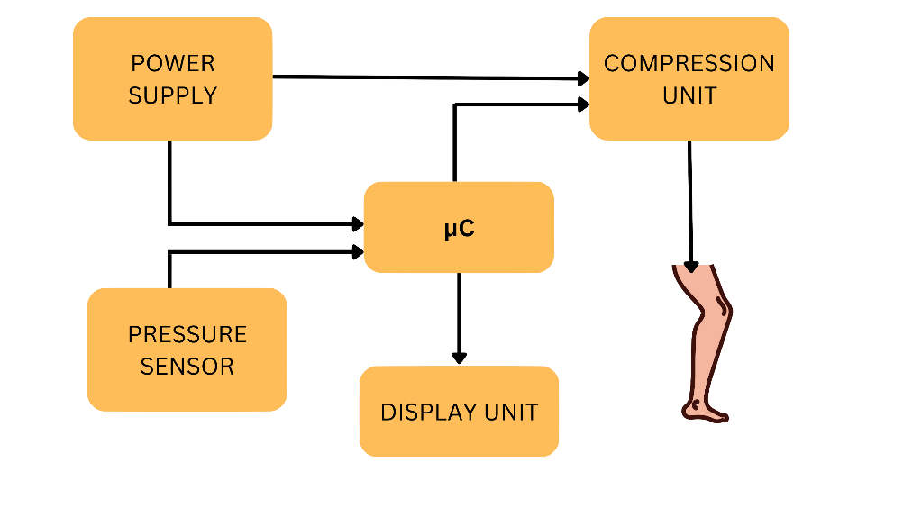

*Figure 3: System Architecture*

The figure above is a visual overview of the proposed intermittent pneumatic compression device. It consists of the power supply unit, compression unit, display unit and a sensor unit. A microcontroller is at the centre of this system architecture and ties all the components together.

## SYSTEM DESIGN

### Compression Unit

The compression unit is what will provide relief to the patient making use of the IPC device. Its components include;

1. Pneumatic pump
2. Cuff
3. Extension hose
4. Solenoid valve

The pneumatic pump supplies air at a specified pressure to be sent to the cuff. An electrical pump will be used to allow the microcontroller to regulate the inflation and deflation phases. The power required for a small pneumatic pump is 6 volts to 12 volts. A small pneumatic pump is adequate since the mean pressure at which the air would be inflated is 35 mmHg.

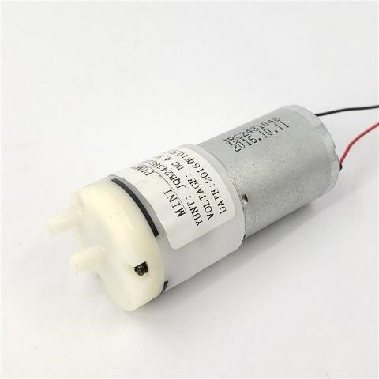

*Figure 4: Pneumatic Pump*

The cuff is wrapped around the limb of the user and is connected to the pneumatic pump which supplies the air. The non-circumferential cuff will be made up of linen and lined with rubber sheets bladders. It will have a width of 65cm with Velcro straps to ensure that it is attached securely to the user.

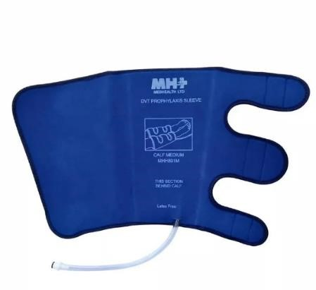

*Figure 5 Cuff*

The extension hose connects the air pump to the cuffs. A silicone-rubber hose will be used because it is highly durable and flexible. It can keep its shape under pressure changes and is suitable for the proposed IPC device design.

The solenoid valve is responsible for keeping the air within the system during the inflation phase and letting it out during the deflation phase. There are two types; normally open and normally closed.

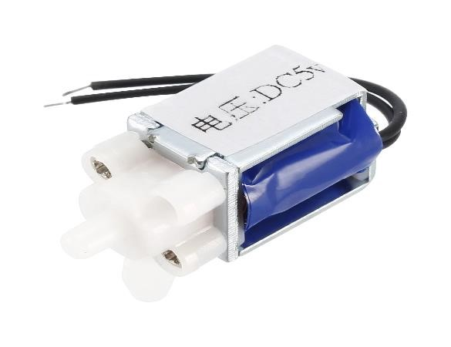

*Figure 6 Solenoid Valve*

### Power Supply Unit

The proposed IPC device will be designed to be portable and so requires a dc power source to power the microcontroller and compression unit.

### Display System

The monitoring system displays the status of the device to show whether it is in a compression state, deflation state or merely idle. The display unit contains the liquid crystal display (LCD).

An LCD (liquid crystal display) is an electronic component illuminated by a light source and is made up of an array of pixels used for the display of information. An LCD module will be used because it is affordable and readily available. It has a working voltage of 3.3 to 5 volts and can display up to 32 characters at a time.

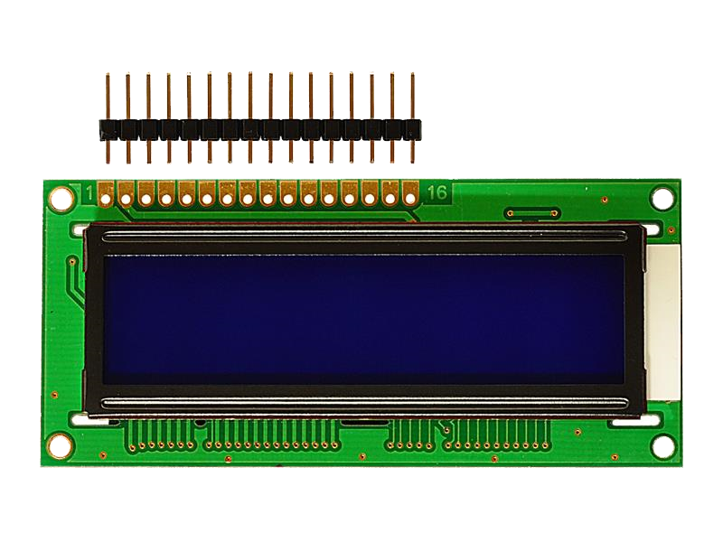

*Figure 7: Liquid Crystal Display*

### Sensor Unit

An air pressure sensor measures changes in air pressure. It will be utilised in the IPC design to monitor the pressure at which air is being pumped into the cuff to ensure optimum constriction and emptying of the vein as well as patient compliance. It has a working voltage of 4.75 to 5.25 volts and can measure pressure up to 170 mmHg.

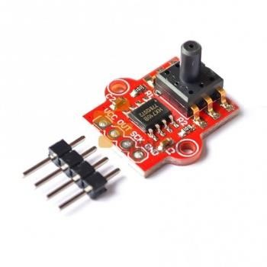

*Figure 8: Air Pressure Sensor*

### Microcontroller

A microcontroller is a single integrated circuit that comprises various elements, including a microprocessor, timers, counters, input/output (I/O) ports, random access memory (RAM), readonly memory (ROM), and some other components. These parts work together to execute a preprogrammed set of specific tasks. The microcontroller board that will be used to build the IPC device is Arduino Uno.

Arduino Uno is a microcontroller board that is based on the ATmega328P. It is made up of 14 digital input/output pins 6 analog inputs, a 16 MHz ceramic resonator, a USB connection, a power jack, an ICSP header and a reset button.

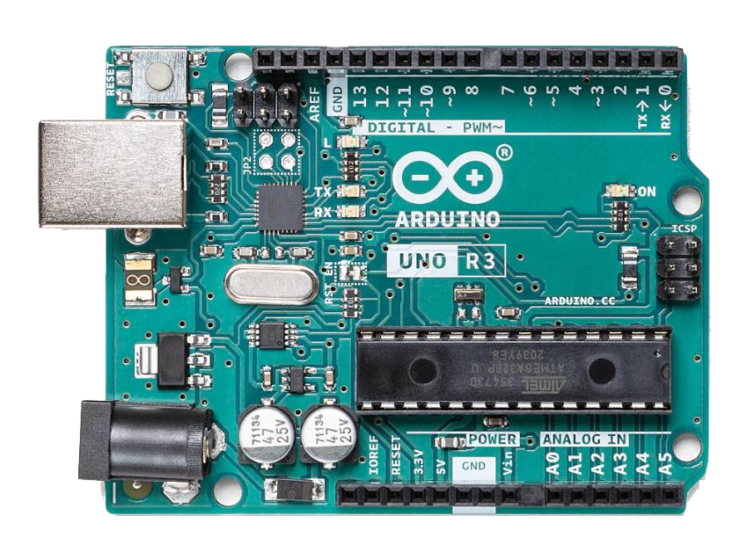

*Figure 9: Arduino Uno Microcontroller*

The Arduino Uno ties all the components together and will contain the necessary commands that will allow the IPC device to function.

### Circuitry

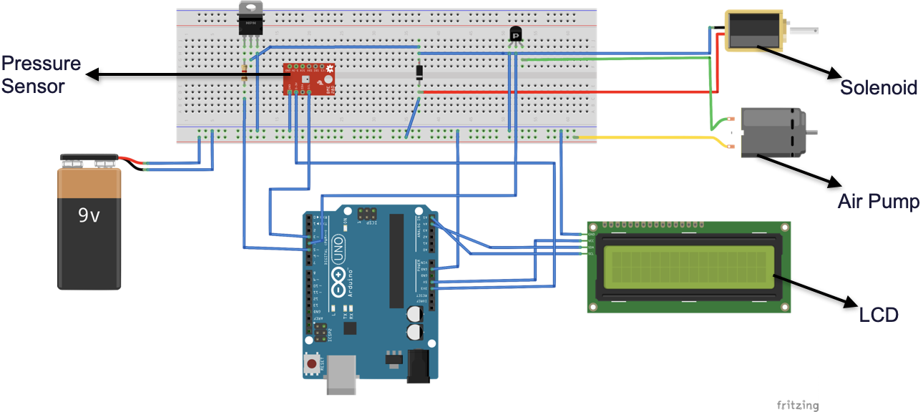

*Figure 10 Breadboard Connection of IPC Device*

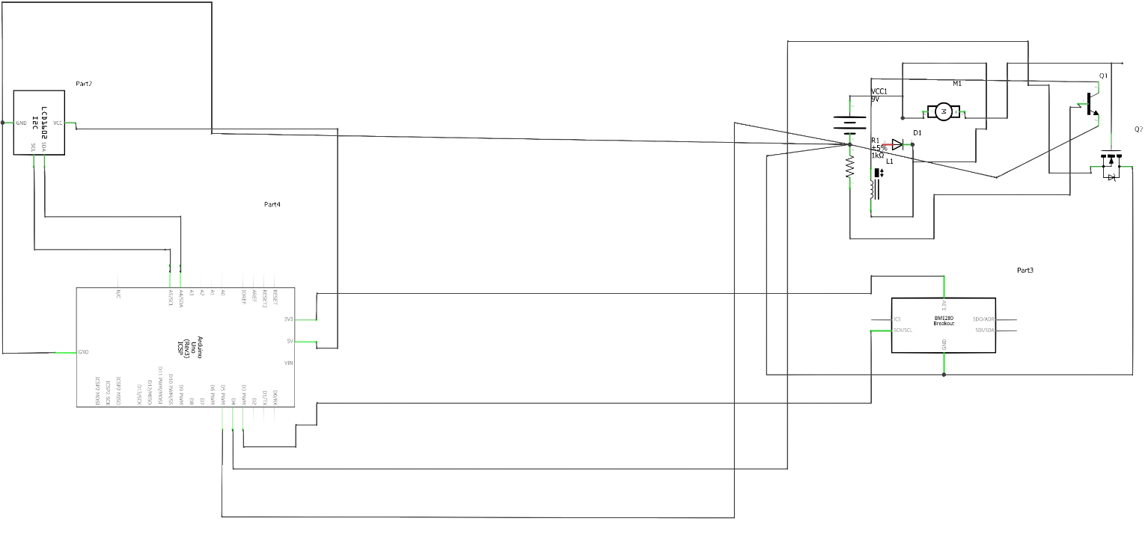

*Figure 11 Schematic Diagram of IPC Device*

The circuitry of the intermittent pneumatic compression device is shown above. The battery holder contains batteries that will supply power to the Arduino Uno and the air pump. All other components receive their power from the microcontroller board. The mosfet is a semiconductor and is interfaced between the air pump and the microcontroller. The mosfet will act as switch for the pump. Because the device works in two phases, the air pump will be inactive during the deflation phase and active during the inflation phase.

The LCD is attached to a PCF8754 chip to reduce the number of connections that will be made to the microcontroller. The pin connections to the microcontroller are;

1. Ground – Ground
2. SDA – A4
3. SCL – A5
4. Vin – 5V

The air pressure sensor’s pin connections to the microcontroller are;

1. Ground – Ground
2. SDA – A4
3. SCL – A5
4. Vin – 3.3V

The solenoid valve is powered by a 9V battery and is interfaced with a TIP41C transistor. A snubber diode is connected across the contacts of the solenoid from the negative side to the positive side of the coil on the breadboard to eliminate transient voltages when power is suddenly lost. A base resistor (1k resistor) is placed on the base pin of the transistor to limit the current going into the base of the transistor. The solenoid’s negative terminal is connected to the collector of the transistor and then a wire is connected from the collector to the emitter. These two act as the switch. The emitter is then connected to the ground of the breadboard making the circuit connection complete [47]. The pin connections to the microcontroller are;

1. Ground – Ground
2. VCC – 5V
3. Resistor – Pin 4

### Flowchart for IPC Device

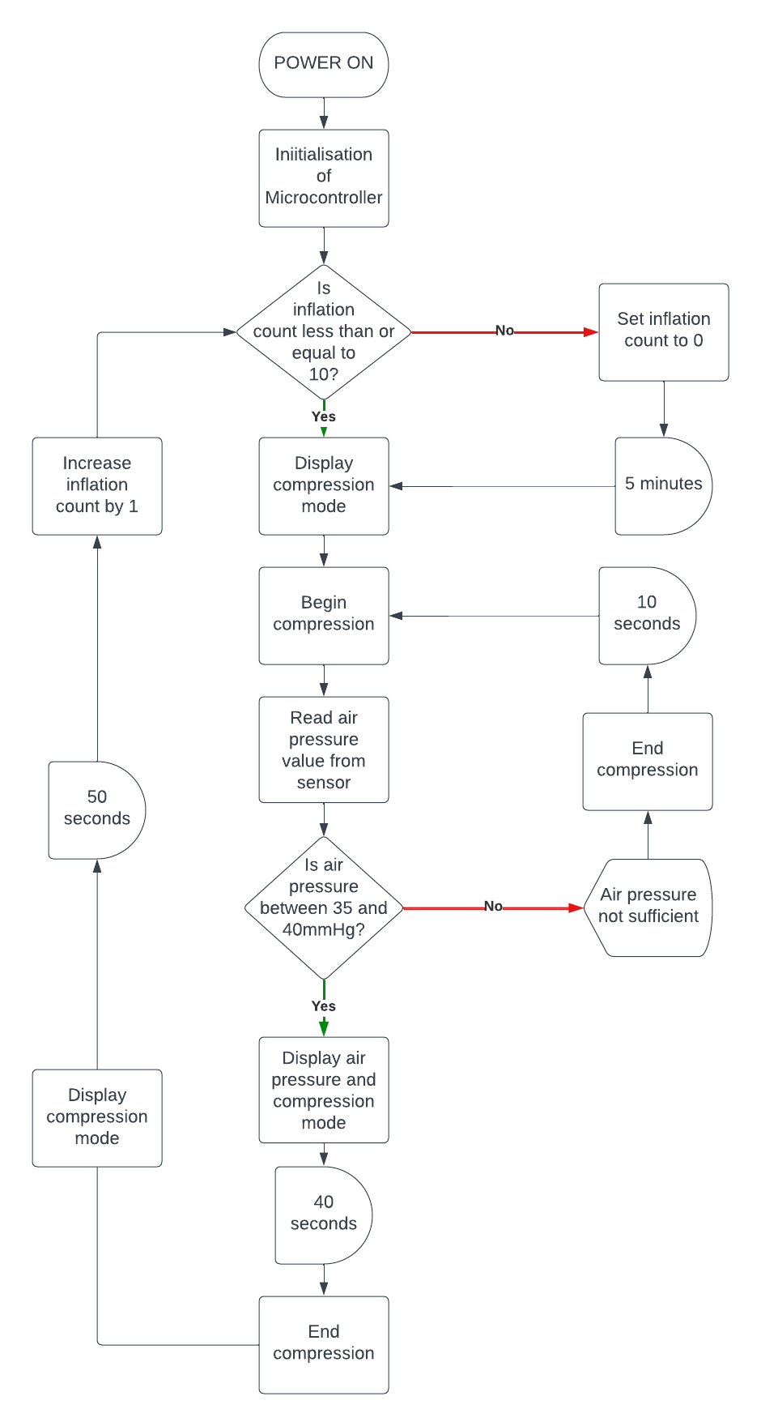

*Figure 12 Flowchart Showing Algorithm*

# BUILDING AND TESTING

## THE CUFF

To design a cuff that can fit people of different calf sizes, 30 people with different body mass indices gave consent and were used as research subjects. After calculating the BMI for each individual, the circumference of their calf was measured and recorded.

After calculations, a range of body mass indices corresponded to a range of calf circumferences. This was essential in determining the cuff circumference for our design.

|  |  |
| --- | --- |
| **BODY MASS INDEX** | **CALF CIRCUMFERENCE (cm)** |
| 16-17 | 29-33 |
| 18-20 | 34-38 |
| 21-23 | 39-41 |
| 24-27 | 42-45 |

The circumference of the cuff was 46 centimeters to accommodate people of varying body mass indices.

The bladder inside the cuff was made of silicone which has the following properties [48]; a. Non-toxic

1. Elastic to accommodate inflation
2. Non-reactive
3. Sealing abilities
4. High tensile strength

The sleeve of the cuff, which encases the bladder was made of nylon with the following properties

[49];

1. Abrasion resistant
2. Biocompatible
3. Water resistant
4. Resilient

The velcro serves as an attachment point in the cuff. To determine the adhesive force of the velcro, the pressure equation, 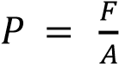 was used.

The pressure coming into the cuff should be proportional to the adhesive force of the velcro, keeping the area constant. With this calculation, the ideal area of the velcro to accommodate the pressure from the air pump was found and used.

Considering the calf circumferences and properties of the bladder and sleeve, the cuff for the IPC device was designed and built.

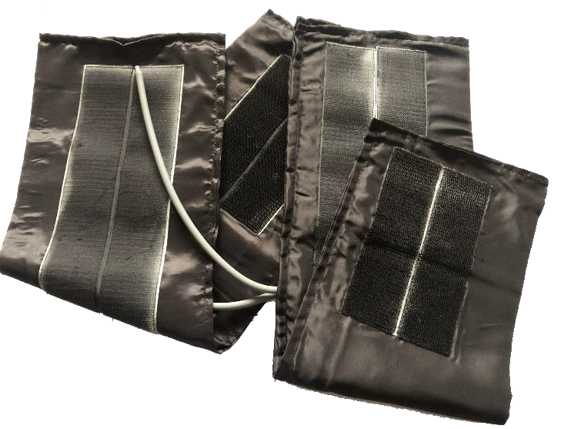

*Figure 13 Built Cuff*

## THE CHASSIS

Based on the schematic diagram developed, the connections were made to the Arduino microcontroller. A chassis was 3D printed to house the components after connection.

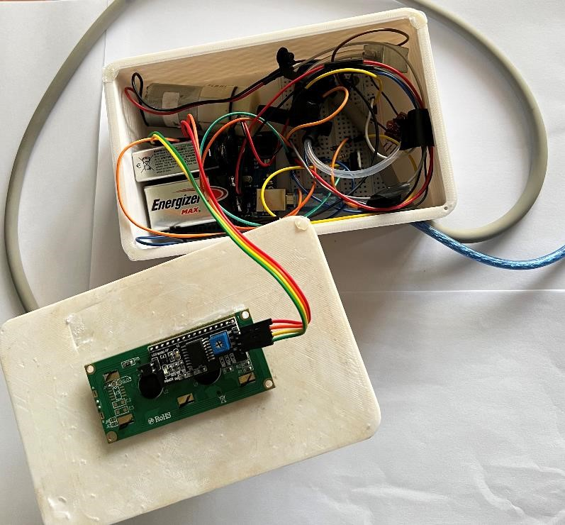

*Figure 14 Breadboard Connections*

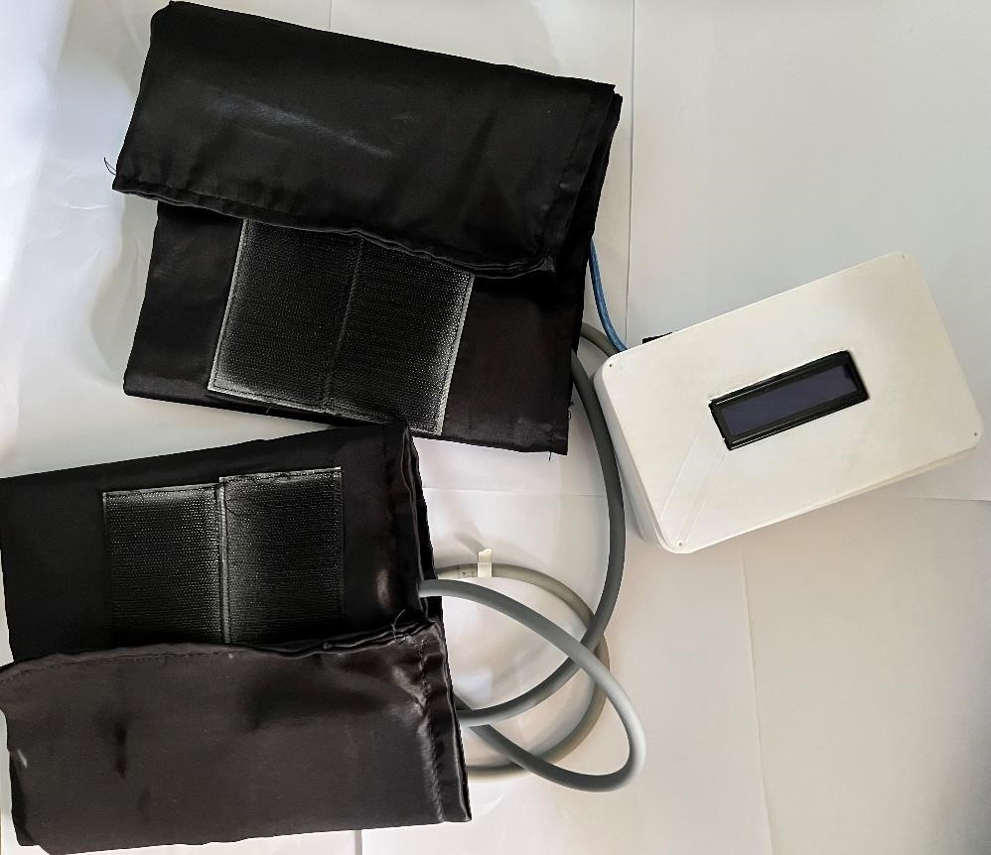

*Figure 15 IPC Device*

From the flowchart, the inflation phase is set to last for 40 seconds to allow for optimal constriction of the gastrocnemius and popliteal vein.

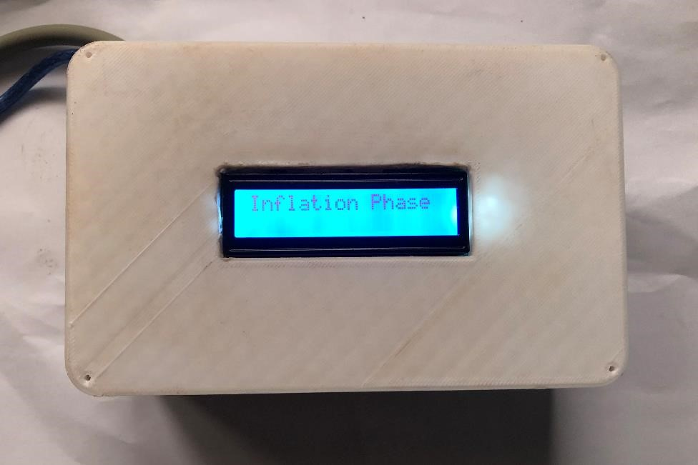

*Figure 16 IPC Device in Inflation Phase*

The deflation phase is set to last for 50 seconds to allow the popliteal vein to be refilled with blood. The pressure with which the popliteal vein is being refilled will allow blood to flow back to the heart.

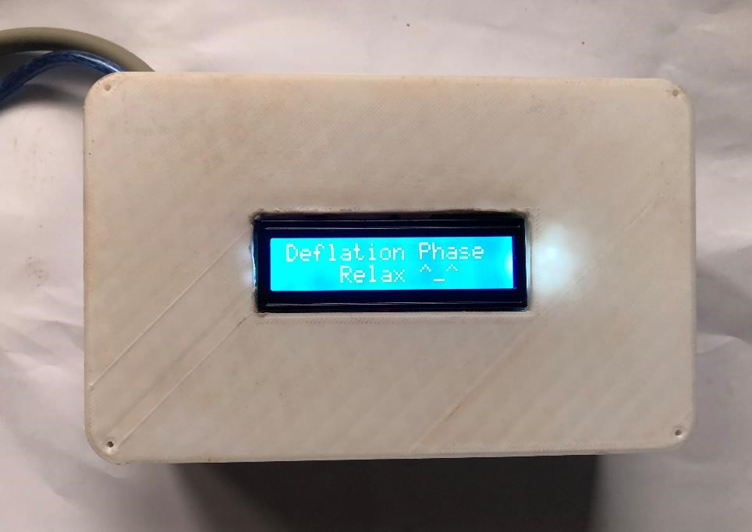

*Figure 17 IPC Device in Deflation Phase*

After 10 cycles of inflation and deflation, a cool down time of 5 minutes is employed. This cool down time ensures that pressure sores are not developed by the user due to constant application of pressure on the skin by the cuff.

## TESTING AND EVALUATION

Each of the components were tested separately to ensure efficiency. Upon assembly, the following tests were carried out on the device;

1. Leakage test
2. Tensile strength of bladder
3. Sensitivity of air pressure sensor
4. Adhesive strength of velcro
5. Constriction of popliteal vein
6. Refilling of popliteal vein

### Leakage Test

An air leakage test was carried out on the bladder inside the cuff to ensure that air does not leave the bladder during the inflation phase. In a case where there is leakage, a pressure range of 35 to 40mmHg cannot be achieved. To carry out the leakage test, the bladder was connected to an air pressure sensor and an air pump. The air pump filled the bladder with air for 20 seconds before stopping. The pressure sensor monitored the pressure in the bladder when the outlets were closed.

The results of the air leakage test showed that the pressure in the bladder was constant when all outlets were closed. This confirmed that there was no air leakage in the bladder.

### Tensile Strength of Bladder

The tensile strength of a material is the stress it can withstand while being stretched without failing. The bladder in the cuff is made of silicone rubber. The tensile strength of the bladder is important because it ensures that there will be no failure of the bladder from expansion during the inflation phase. According to literature review, the tensile strength of silicone rubber is between 1.4 - 8.9Mpa.

To test the tensile strength of the bladder, air was continuously pumped into the bladder for two minutes and the outlets were shut for two minutes.

The results of this test confirmed that the tensile strength of the silicone bladder was indeed high and would withstand the pressure changes in the device without failing.

### Sensitivity of Air Pressure Sensor

Sensitivity is the ratio of the changes in the output of an instrument to the change in the value of the quantity being measured. Because the pressure is being applied to the leg, it is necessary to have a pressure sensor with a high sensitivity to record the smallest changes in pressure in the bladder of the cuff.

To test the sensitivity of the air pressure sensor, the sensor is connected to a bladder and an air pump. The outlets are closed, and the air pump inflates the bladder for 20 seconds. Air is then released from the bladder bit by bit, and the pressure sensor records the readings.

The results of the leakage test showed that the air pressure sensor was able to record small changes in air pressure in the bladder.

### Adhesive Strength of Velcro

Adhesive strength is the resistance of an adhesive material (Velcro) to separation. This feature is very important because it ensures that the cuff does not open. To test the adhesive strength of the velcro on the cuff, a simple peel test was carried out.

The results of the peel test showed that the area of the velcro was indeed large enough to accommodate the increased air pressure during the inflation phase without opening up.

### Constriction of Popliteal Vein

Constriction of the vein in a human body is associated with a slower blood flow rate. Constriction is important during the inflation phase because it shows that pressure is being applied to the popliteal vein.

To test for constriction in the popliteal vein, we had our 30 research subjects make use of the device for 5 phases each. Feedback we received from the test subjects showed that 70% of them started to feel a tingling sensation underneath their feet in the 2nd and 3rd inflation phase.

Upon further research, it was confirmed that the tingling sensation underneath the feet corresponds to restriction of blood flow in a blood vessel [50]. This feedback further confirmed that we were able to constrict the popliteal vein during the inflation phase.

### Refilling of Popliteal Vein

The main goal of the IPC device is to prevent deep vein thrombosis by improving blood flow to the heart from the deep vein. Refilling of the popliteal vein after constriction ensures that there is an increased pressure in the vein as blood rushes in to improve blood flow.

To test for refilling of the popliteal vein, feedback was taken from the research subjects who experienced the tingling sensation during the inflation phase.

The results from the feedback showed that the research subjects experienced a reduction in the tingling sensation they felt. This implies that there is a refilling of the popliteal vein as the tingling sensation they felt gradually went away.

# CONCLUSION AND RECOMMENDATION

## ASSESSMENT OF OBJECTIVES

The aim of our project was to develop an affordable and effective way of preventing deep vein thrombosis from occurring, especially in patients who are undergoing recovery after surgery. At the end of the project, we were able to design an effective compression device to prevent abnormal blood clot formation in the deep veins found in the calf.

Our device is affordable as we utilized available materials on the Ghanaian market in building the device and can be patronized by the average Ghanaian. Again, to contribute to keeping a clean and healthy environment, we recycled bladders of abandoned blood pressure cuffs from the Komfo Anokye Teaching Hospital to be used as bladders in our cuffs.

We had the opportunity of putting into practice and applying knowledge we obtained mainly in electronics and programming in our four-year study of Biomedical engineering.

## CHALLENGES

Although we were able to achieve our objectives, we encountered some challenges while building the intermittent pneumatic compression device.

* The air pressure sensor had a very good sensitivity because it could detect small changes in pressure. The expected pressure reading was between 35mmHg – 40mmHg. However, it was unable to read past the pressure of 7.5mmHg. There was no proper documentation on the air pressure sensor and so much could not be done about it.
* Contact issues were developed with the breadboard because we could not implement the designing of a printed circuit board (PCB) due to the issues that arose with the air pressure sensor.

## RECOMMENDATIONS

Our solution is an effective and affordable way of preventing deep vein thrombosis from occurring and hence should be adopted and used as a method of preventing deep vein thrombosis since there is none available in the country now.

In order to improve the efficiency of the device, a dedicated power source, either from the mains or a rechargeable battery, should be used for the device. Also, we could give back to the research environment by testing the device on more individuals to enrich the current dataset. Finally, in our literature review, we established that there were varying compression types, that is calf compression, thigh compression, ankle compression and foot compression. Our device focused on calf compression. In further works, the other compression types could be tested to see which compression type would be more effective for Ghanaians.

# APPENDIX

## CODE IMPLEMENTATION



*Figure 18 Code Implementation for IPC Device 1*



*Figure 19 Code Implementation of IPC Device 2*



*Figure 20 Code Implementation of IPC Device 3*

## 3D MODEL OF DEVICE

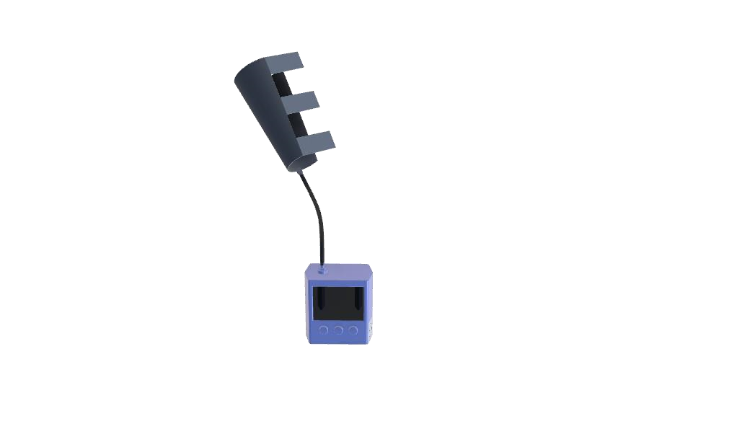

*Figure 21 3D Design of IPC Device*

## BILL OF MATERIALS

|  |  |  |
| --- | --- | --- |
| **ITEM** | **QUANTITY** | **AMOUNT**  **(Ghc)** |
| BATTERY | 2 | 90.00 |
| ARDUINO UNO | 1 | 130.00 |
| AIR PRESSURE SENSOR | 1 | 25.00 |
| CUFF MATERIAL (NYLON) | 1 | 15.00 |
| VELCRO | 1 | 4.00 |
| MODEL | 1 | 412.00 |
| PUMP | 1 | 32.00 |
| SOLENOID VALVE | 1 | 18.00 |
| I2C LCD | 1 | 40.00 |
| OTHER ELECTONIC  COMPONENTS |  | 20.00 |
| **TOTAL** |  | **769.00** |

# REFERENCES

1. “What is Venous Thromboembolism?” <https://www.cdc.gov/ncbddd/dvt/facts>(accessed Apr. 28, 2023).
2. “Deep vein thrombosis UK.” [https://www.nhsinform.scot/illnesses-and-conditions/blood-andlymph/deep-vein-thrombosis](https://www.nhsinform.scot/illnesses-and-conditions/blood-and-lymph/deep-vein-thrombosis) (accessed Apr. 28, 2023).
3. Ministry of Health Ghana, *Standard Treatment Guidelines*, 7th ed. 2017.
4. “Physiology of Circulation | SEER Training.” <https://training.seer.cancer.gov/anatomy/cardiovascular/blood/physiology.html>(accessed Apr. 28, 2023).
5. “16.5A: Overview of Hemostasis - Medicine LibreTexts.”

[https://med.libretexts.org/Bookshelves/Anatomy_and_Physiology/Anatomy_and_Physiology_(Bo undless)/16%3A_Cardiovascular_System_-](https://med.libretexts.org/Bookshelves/Anatomy_and_Physiology/Anatomy_and_Physiology_(Boundless)/16%3A_Cardiovascular_System_-_Blood/16.5%3A_Hemostasis/16.5A%3A_Overview_of_Hemostasis)

[_Blood/16.5%3A_Hemostasis/16.5A%3A_Overview_of_Hemostasis](https://med.libretexts.org/Bookshelves/Anatomy_and_Physiology/Anatomy_and_Physiology_(Boundless)/16%3A_Cardiovascular_System_-_Blood/16.5%3A_Hemostasis/16.5A%3A_Overview_of_Hemostasis) (accessed Apr. 28, 2023).

1. K. McLendon, A. Goyal, and M. Attia, *Deep Venous Thrombosis Risk Factors*. 2022. Accessed: Mar. 20, 2023. [Online]. Available: <https://www.ncbi.nlm.nih.gov/books/NBK470215/>
2. S. Z. Goldhaber and H. Bounameaux, “Pulmonary embolism and deep vein thrombosis,” *The Lancet*, vol. 379, no. 9828, pp. 1835–1846, May 2012, doi: 10.1016/S0140-6736(11)61904-1.
3. “Blood Clots After Surgery.” <https://www.webmd.com/dvt/blood-clots-after-surgery>(accessed Apr. 28, 2023).
4. M. S. Hamza and S. A. Mousa, “Cancer-Associated Thrombosis: Risk Factors, Molecular Mechanisms, Future Management,” *Clinical and Applied Thrombosis/Hemostasis*, vol. 26, p.

107602962095428, Jan. 2020, doi: 10.1177/1076029620954282.

1. G. A. A. M. McLendon K, “Deep Venous Thrombosis Risk Factors.”.
2. “Cancer and the risk of blood clots.” [https://www.cancerresearchuk.org/aboutcancer/coping/physically/cancer-and-the-risk-of-blood-clots](https://www.cancerresearchuk.org/about-cancer/coping/physically/cancer-and-the-risk-of-blood-clots) (accessed Apr. 28, 2023).
3. “Obesity and Deep Vein Thrombosis (DVT).” [https://www.news-medical.net/health/Obesity-anddeep-vein-thrombosis-](https://www.news-medical.net/health/Obesity-and-deep-vein-thrombosis-%28DVT%29.aspx#:~:text=Obesity%20also%20raises%20the%20other%20known%20risk%20factors,PE.%20Obesity%20doubles%20the%20risk%20of%20such%20imbalances)

[%28DVT%29.aspx#:~:text=Obesity%20also%20raises%20the%20other%20known%20risk%20fa ctors,PE.%20Obesity%20doubles%20the%20risk%20of%20such%20imbalances.](https://www.news-medical.net/health/Obesity-and-deep-vein-thrombosis-%28DVT%29.aspx#:~:text=Obesity%20also%20raises%20the%20other%20known%20risk%20factors,PE.%20Obesity%20doubles%20the%20risk%20of%20such%20imbalances) (accessed Apr.

28, 2023).

1. “Understand Your Risk for Excessive Blood Clotting.” heart.org/en/health-topics/venousthromboembolism/understand-your-risk-for-excessive-blood-clotting (accessed Apr. 28, 2023).
2. M. Ratini, M S, and D O, “Deep Vein Thrombosis in Pregnancy,” *GrowbyWebMD*, Oct. 2022,

Accessed: Mar. 31, 2023. [Online]. Available: <https://www.webmd.com/baby/dvt-pregnancy>

1. “Blood clots and pregnancy.[” https://www.marchofdimes.org/find-support/topics/pregnancy/bloodclots-and-pregnancy](https://www.marchofdimes.org/find-support/topics/pregnancy/blood-clots-and-pregnancy) (accessed Apr. 28, 2023).
2. A. L. Shiloh, C. McPhee, L. Eisen, S. Koenig, and S. J. Millington, “Better With Ultrasound,” *Chest*, vol. 158, no. 3, pp. 1122–1127, Sep. 2020, doi: 10.1016/j.chest.2020.01.038.
3. R. H. White, J. P. McGahan, M. M. Daschbach, and R. P. Hartling, “Diagnosis of deep-vein thrombosis using duplex ultrasound,” *Ann Intern Med*, vol. 111, no. 4, pp. 297–304, 1989, doi:

10.7326/0003-4819-111-4-297.

1. Cheung Maureen E., Singh Vikramjeet, and Firstenberg Michael S., “Duplex Ultrasound.” <https://www.ncbi.nlm.nih.gov/books/NBK459266/?report=printable>(accessed Apr. 28, 2023).
2. H. Ames, “D-dimer test results: What is the normal range?,” *MEDICALNEWSTODAY*, Dec. 2022, Accessed: Mar. 30, 2023. [Online]. Available: [https://www.medicalnewstoday.com/articles/ddimer-test-results-what-is-the-normal-range](https://www.medicalnewstoday.com/articles/d-dimer-test-results-what-is-the-normal-range)
3. N. R. Fogoros, “How Deep Vein Thrombosis Is Diagnosed ,” *verywell health*, Oct. 30, 2022.

<https://www.verywellhealth.com/deep-vein-thrombosis-diagnosis-1746132>(accessed Mar. 30, 2023).

1. C. o. Umerah and I. I. Momodu, “Anticoagulation,” *Decision-Making in Orthopedic and Regional*

*Anesthesiology: A Case-Based Approach*, pp. 47–52, Jul. 2022, doi:

10.1017/CBO9781316145227.010.

1. E. DeYoung and J. Minocha, “Inferior Vena Cava Filters: Guidelines, Best Practice, and Expanding Indications,” *Semin Intervent Radiol*, vol. 33, no. 02, pp. 065–070, May 2016, doi: 10.1055/s-00361581088.
2. S. Grewal, M. R. Chamarthy, and S. P. Kalva, “Complications of inferior vena cava filters,” *Cardiovasc Diagn Ther*, vol. 6, no. 6, pp. 632–641, Dec. 2016, doi: 10.21037/cdt.2016.09.08.
3. S. Mathews and O. De Jesus, “Thrombectomy,” *Encyclopedia of Clinical Neuropsychology*, pp. 3461–3462, Feb. 2023, doi: 10.1007/978-3-319-57111-9_9278.
4. R. Morgan and A.-M. Belli, “Percutaneous thrombectomy: a review,” *European Radiology 2001 12:1*, vol. 12, no. 1, pp. 205–217, Jul. 2001, doi: 10.1007/S003300101014.
5. A. N. Nicolaides, V. V. Kakkar, E. S. Field, and P. Fish, “Optimal electrical stimulus for prevention of deep vein thrombosis,” *Br Med J*, vol. 3, no. 5829, p. 756, Sep. 1972, doi:

10.1136/BMJ.3.5829.756.

1. N. L. Browse and D. Negus, “Prevention of Postoperative Leg Vein Thrombosis by Electrical Muscle Stimulation. An Evaluation with 125I-Labelled Fibrinogen,” *Br Med J*, vol. 3, no. 5723, pp.

615–618, Sep. 1970, doi: 10.1136/bmj.3.5723.615.

1. C. S. Lim and A. H. Davies, “Graduated compression stockings,” *Can Med Assoc J*, vol. 186, no. 10, pp. E391–E398, Jul. 2014, doi: 10.1503/cmaj.131281.
2. R. J. Morris, “Intermittent pneumatic compression—systems and applications,” *J Med Eng Technol*, vol. 32, no. 3, pp. 179–188, Jan. 2008, doi: 10.1080/03091900601015147.
3. L. G. HERRMANN, “PASSIVE VASCULAR EXERCISES,” *Archives of Surgery*, vol. 29, no. 5,

p. 697, Nov. 1934, doi: 10.1001/archsurg.1934.01180050002001.

1. W. S. Collens and N. D. Wilensky, “The use of intermittent venous compression in the treatment of peripheral vascular disease,” *Am Heart J*, vol. 11, no. 6, pp. 705–720, Jun. 1936, doi: 10.1016/S0002-8703(36)90496-9.
2. C. Ferraresi, D. Maffiodo, and H. Hajimirzaalian, “A model-based method for the design of intermittent pneumatic compression systems acting on humans,” *Proc Inst Mech Eng H*, vol. 228, no. 2, pp. 118–126, Feb. 2014, doi: 10.1177/0954411913516307.
3. W. Lee *et al.*, “Investigation of Blood Flow During Intermittent Pneumatic Compression and Proposal of a New Compression Protocol,” *Clinical and Applied Thrombosis/Hemostasis*, vol. 24, no. 2, pp. 338–347, Mar. 2018, doi: 10.1177/1076029616683044.
4. K. Delis, G. Slimani, H. Hafez, and A. Nicolaides, “Enhancing Venous Outflow in the Lower Limb with Intermittent Pneumatic Compression. A Comparative Haemodynamic Analysis on the Effect of Foot vs. Calf vs. Foot and Calf Compression,” *European Journal of Vascular and Endovascular Surgery*, vol. 19, no. 3, pp. 250–260, Mar. 2000, doi: 10.1053/ejvs.1999.1048.
5. J. M. Zhao, M. L. He, Z. M. Xiao, T. S. Li, H. Wu, and H. Jiang, “Different types of intermittent pneumatic compression devices for preventing venous thromboembolism in patients after total hip replacement,” *Cochrane Database of Systematic Reviews*, Dec. 2014, doi:

10.1002/14651858.CD009543.pub3.

1. M. C. Proctor, L. J. Greenfield, T. W. Wakefield, and P. J. Zajkowski, “A clinical comparison of pneumatic compression devices: the basis for selection,” *J Vasc Surg*, vol. 34, no. 3, pp. 459–464, 2001, doi: 10.1067/MVA.2001.117884.
2. E. W. Salzman *et al.*, “Effect of optimization of hemodynamics on fibrinolytic activity and antithrombotic efficacy of external pneumatic calf compression.,” *Ann Surg*, vol. 206, no. 5, p. 636, 1987, doi: 10.1097/00000658-198711000-00014.
3. C. R. Lattimer, E. Kalodiki, M. Azzam, and G. Geroulakos, “Pneumatic thigh compression reduces calf volume and augments the venous return,” [*http://dx.doi.org/10.1177/0268355514526183*,](http://dx.doi.org/10.1177/0268355514526183) vol.

30, no. 5, pp. 316–322, Mar. 2014, doi: 10.1177/0268355514526183.

1. R. J. Morris and J. P. Woodcock, “Evidence-Based Compression,” *Ann Surg*, vol. 239, no. 2, pp. 162–171, Feb. 2004, doi: 10.1097/01.sla.0000109149.77194.6c.
2. K. T. Delis, G. Slimani, H. M. Hafez, and A. N. Nicolaides, “Enhancing Venous Outflow in the Lower Limb with Intermittent Pneumatic Compression. A Comparative Haemodynamic Analysis on the Effect of Foot vs. Calf vs. Foot and Calf Compression,” *Eur J Vasc Endovasc Surg*, vol. 19, pp. 250–260, 2000, doi: 10.1053/ejvs.1999.1048.
3. E.-K. Tan and L.-L. Chan, “Neurovascular compression syndromes and hypertension: clinical relevance,” *Nat Clin Pract Neurol*, vol. 3, no. 8, pp. 416–417, Aug. 2007, doi: 10.1038/ncpneuro0558.
4. E. A. , R. J. L. , T. R. , & N. W. Lachmann, “Complications associated with intermittent pneumatic compression.,” 1992.
5. “Lithotomy Position Definition, Procedure, birth, Complications.”

[https://www.healthcaretip.com/2017/05/Lithotomy-position-Definition-Procedure-birthComplications.html#:~:text=Lithotomy%20is%20a%20position%20similar%20to%20the%20posi tion,during%20urologic%2C%20gynecologic%20and%20proctologic%20examinations%20of%20 body.](https://www.healthcaretip.com/2017/05/Lithotomy-position-Definition-Procedure-birth-Complications.html#:~:text=Lithotomy%20is%20a%20position%20similar%20to%20the%20position,during%20urologic%2C%20gynecologic%20and%20proctologic%20examinations%20of%20body) (accessed Mar. 31, 2023).

1. A. Anand, A. U. Siddiqui, T. G. Buchman, and R. S. Hotchkiss, “Complications Associated with Intermittent Pneumatic Compression Devices,” *Anesthesiology*, vol. 93, no. 6, pp. 1556–1556, Dec.

2000, doi: 10.1097/00000542-200012000-00047.

1. “Common peroneal nerve dysfunction.” [https://www.mountsinai.org/health-library/diseasesconditions/common-peroneal-nerve-dysfunction](https://www.mountsinai.org/health-library/diseases-conditions/common-peroneal-nerve-dysfunction) (accessed Mar. 31, 2023).
2. A. Anand, “Complications Associated with Intermittent Pneumatic Compression Devices,” *Anesthesiology*, vol. 93, no. 6, pp. 1556–1556, Dec. 2000, doi: 10.1097/00000542-20001200000047.
3. Chris, “Controlling A Solenoid Valve With Arduino,” *BC ROBOTICS*, Jul. 02, 2015.
4. Team Xometry, “7 Properties of Silicone,” Jul. 27, 2022.
5. Team Xometry, “7 Properties of Nylon: Everything you Need to Know,” Jun. 23, 2022.
6. “Poor circulation: Symptoms, causes, treatment, and more.” <https://www.medicalnewstoday.com/articles/322371#symptoms>(accessed Aug. 31, 2023).